PaperPilot – GenAI Research Paper Assistant

Software Requirements Specification (SRS)
Team: Team-1

Team Members: Harish Kumar | Kalpana Bhardwaj | Vansh Imlani | Anshul

Faculty Superviser: Mr. Saqib

Mentor: Mr. Zuber

University: Jagannath University

1. Introduction

1.1 Purpose
The purpose of this document is to provide a detailed description of the PaperPilot system, including its functionality, constraints, and requirements. This SRS serves as a reference for developers, testers, and stakeholders to understand the system clearly.

1.2 Scope
PaperPilot is a web-based AI-powered research assistant that enables users to upload research papers (PDFs) and extract meaningful insights using Generative AI.
The system provides:
- Secure user authentication (Login/Signup)
- Uploading research papers (PDF format)
- AI-generated summaries
- Structured notes generation
- Context-aware chatbot (RAG-based)

1.3 Intended Audience
- Developers
- Project Evaluators / Teachers
- Researchers / Students
- System Testers

1.4 Definitions & Acronyms
- AI: Artificial Intelligence
- RAG: Retrieval Augmented Generation
- LLM: Large Language Model
- PDF: Portable Document Format
- UI: User Interface
- Vector Database: A specialized database (like ChromaDB) used to store and search numerical representations of text.
- Embeddings: Converting text into numbers (using HuggingFace) so the AI can understand meaning and context.

2. Overall Description

2.1 Product Perspective
PaperPilot is a standalone web application developed using:
- Frontend/UI: Streamlit
- Backend & Pipeline: Python, LangChain framework
- AI Integration: Groq API (Model: llama-3.3-70b-versatile)
- Vector Database: ChromaDB (for local semantic search)
- Embeddings: HuggingFace
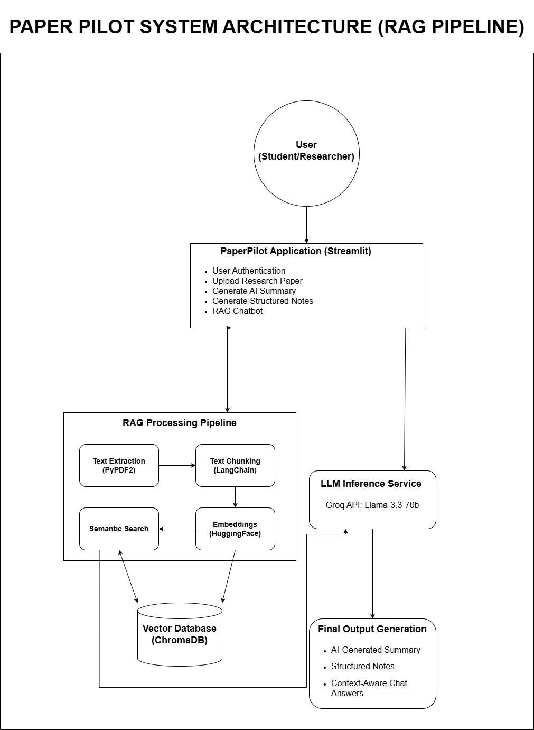

2.2 Product Functions
The system performs the following functions:
- User Registration and Login
- Uploading research papers
- Processing PDF documents
- Generating summaries
- Generating structured notes
- Providing chatbot-based Q&A

2.3 User Classes
- General User: Uploads papers and uses AI features
- Admin (Optional): System monitoring (future scope)

2.4 Operating Environment
- OS: Windows/Linux/Mac
- Browser: Chrome, Edge
- Platform: Localhost (Streamlit)

2.5 Constraints
- Requires internet connection for AI API
- Supports only PDF files
- File size limitations (e.g., 200MB max)

2.6 Assumptions
- Users have basic knowledge of file upload
- API keys are properly configured in .env file

3. System Features
3.1 User Authentication
Description:
Allows users to log in or create an account.
Functional Requirements:
- User can enter email and password
- System validates credentials
- Displays error on invalid login
- Allows new account creation

3.2 Upload Research Paper
Description:
Users can upload a PDF research paper.
Functional Requirements:
- Upload via drag & drop or browse
- Accept only PDF files
- Show success message after processing
- Store file temporarily

3.3 Generate AI Summary
Description:
Generates a concise summary of the uploaded paper.
Functional Requirements:
- Button to generate summary
- AI processes text and returns summary
- Display result on screen

3.4 Generate Structured Notes
Description:
Extracts structured notes including introduction, key points, and conclusion.
Functional Requirements:
- Button to generate notes
- Output includes:
  - Introduction
  - Key Points
  - Conclusion

3.5 RAG Chatbot
Description:
Allows users to ask questions related to the uploaded paper.
Functional Requirements:
- Input field for questions
- Context-based answer generation
- Uses uploaded PDF as knowledge base

4. External Interface Requirements

4.1 User Interface
- Simple and clean dashboard
- Sidebar navigation:
  - Upload Paper
  - Generate Summary
  - Generate Notes
  - Chatbot

4.2 Hardware Interface
- Standard PC/Laptop

4.3 Software Interface
- Python environment
- Streamlit framework
- AI API (Groq or similar)

5. Non-Functional Requirements

5.1 Performance
- Fast response time for AI outputs
- Efficient PDF processing

5.2 Security
- API key stored securely in .env
- User authentication required

5.3 Usability
- Easy-to-use interface
- Minimal learning curve

5.4 Reliability
- Stable response generation
- Proper error handling

5.5 Scalability
- Can be extended to multiple users
- Future cloud deployment possible

6. Future Enhancements
- Multi-file upload
- Download summary/notes as PDF
- Cloud storage integration
- User history tracking

